CS 305 Project One

Document Revision History

Version | Date | Author | Comments
1.0 | 2026/03/20 | Vernon Dodo

Client



Developer
Vernon Dodo

1. Interpreting Client Needs

Given that Artemis Financial is a financial services company, it is safe to assume that it handles highly sensitive financial planning data, including savings, retirement, investments, and insurance information. Due to the nature of their data, secure communication is essential to protect confidentiality, integrity, and client trust. Secure communication also reduces the risk of cyberattacks, ensures compliance with regulations that govern both the financial services and technology sectors, and supports operational resilience.

Since the brief states that, “The software is for entrepreneurs, businesses, and government agencies around the world”, meaning that they might exchange data across borders, we can safely assume that they either currently, or will be in the future, producing international transactions. This would require an awareness of international data protection laws and potential restrictions on cryptographic technologies.

Besides the international laws discussed in the preceding paragraph, there are government restrictions to consider about secure communication. These restrictions exist in the form of regulations or laws that govern the transmission, distribution, and storage of secure communications. For the United States specifically the following laws govern secure communications:
- Electronic Communications Privacy Act of 1986 (ECPA)
- Stored Communications Act (SCA)
- Secure and Trusted Communications Networks Act (2019)
- Code of Federal Regulation Part 791 – Securing the Information and Communications Technology and Services Supply Chain

Artemis, as a financial services provider, would be a prime target for current and emerging threats, such as:
- Man-in-the-middle attacks
- Injection attacks due to unvalidated inputs
- Credential theft and authentication bypass
- API enumeration and denial-of-service attacks
- Supply-chain vulnerabilities from outdated open-source libraries

To modernize securely, I would take into consideration the following practices:
- Actively maintaining open-source libraries
- Incorporating modern web application technologies such as TLS 1.3, and secure API design
- Including automated dependency scanning
- Integrating secure coding practices into development workflows

2. Areas of Security

According to the vulnerability assessment process flow, an architecture review determines which manual code reviews would be needed, and that the result would be a “Summary of findings with mitigation plan.” It also notes that “Architecture review and optional output from static testing will determine which manual code reviews are necessary.” These guidelines will determine how we select the relevant areas of security for Artemis’ RESTful web application.

Following these guidelines, we have determined the following relevant areas:

- Architecture review
- Relevance: Artemis uses a RESTful web API as a core integration point. An architecture review ensures:
  - Proper separation of concerns (API layer, business logic, data access).
  - Network segmentation (DMZ, internal services, database).
  - Use of TLS termination, API gateways, and Web Application Firewalls(WAFs) where appropriate.
- Why it matters: Financial data and regulatory expectations demand a defensible, well-documented architecture that supports least privilege and secure deployment patterns.
2. Input validation
- Relevance: All REST endpoints accept client-supplied data (e.g., customer details, financial parameters). Without strict validation, Artemis is exposed to injection, XSS (if responses are rendered in a browser), and data corruption.
- Key controls:
  - Server-side validation of all parameters (type, length, format, range).
  - Whitelisting allowed values where possible.
  - Centralized validation routines to avoid inconsistent checks.
3. APIs (secure API interactions)
- Relevance: The primary interface is a RESTful API, making API security central:
  - Authentication (e.g., OAuth2, JWT) and robust authorization checks.
  - Rate limiting and throttling to prevent abuse and DoS.
  - Proper handling of API keys, tokens, and secrets.
- Key controls:
  - Enforce least privilege per endpoint.
  - Avoid exposing internal implementation details in error messages.
  - Use secure API design patterns (idempotency, safe methods, proper status codes).
4. Cryptography (encryption use and vulnerabilities)
- Relevance: Artemis must protect financial data in transit and at rest:
  - TLS for all external and internal API traffic.
  - Strong algorithms and key sizes (no deprecated ciphers).
  - Encrypted storage for sensitive fields (e.g., identifiers, possibly PII).
- Key controls:
  - Use well-maintained crypto libraries; never roll your own.
  - Centralized key management and rotation.
  - Regular review of cipher suites and protocol versions.

5. Client/server (secure distributed composing)
- Relevance: The system is inherently distributed: clients (browsers, mobile apps, partner systems) call the REST API, which in turn talks to backend services and databases.
- Key controls:
  - Mutual trust boundaries clearly defined between client, API, and backend.
  - Use of secure channels between all tiers.
  - Avoid trusting client-side logic for security decisions.

6. Code error / secure error handling
- Relevance: Poor error handling can leak stack traces, SQL queries, or internal details that attackers can exploit.
- Key controls:
  - Generic error messages to clients; detailed logs only on the server.
  - Consistent exception handling strategy across the codebase.
  - No sensitive data in logs (e.g., full account numbers, secrets).

7. Code quality / secure coding practices and data structures
- Relevance: Long-term security depends on maintainable, high-quality code:
  - Avoid common vulnerabilities (OWASP Top 10) through patterns and reviews.
  - Use safe data structures and libraries that minimize risk (e.g., prepared statements, ORM).
- Key controls:
  - Coding standards that include security requirements.
  - Peer reviews and static analysis integrated into CI/CD.
  - Refactoring legacy code that violates secure patterns.

8. Encapsulation (views, models, controllers, data access, services, plug-ins)
- Relevance: The diagram lists layers such as “Views, Models, Controllers, Data Access, Services, Plug-Ins, APIs.” For Artemis, even if the primary interface is an API, the same principle applies:
  - Controllers (API endpoints) should not directly manipulate the database.
  - Business logic should be encapsulated in services.
  - Data access should be centralized and use parameterized queries.
- Key controls:
  - Clear layering to prevent cross-cutting security violations.
  - Minimal exposure of internal objects in API responses.
  - Careful vetting of any plug-ins or third-party modules.

3. Manual Review

Moving on from the area of security assessment, here are 10 concrete vulnerabilities mapped to the security areas from the process flow diagram:

- Hard-coded database credentials (cryptography / client–server)
    - Location: DocData.java
    - Starting on line 21, the read_document function opens a JDBC connection with a hard-coded URL, username and password:
Connection con=DriverManager.getConnection("jdbc:mysql://localhost:3306/test","root","root"); (lines 26 - 27)
    - These lines of code expose the credentials in source control, prevents rotation, and violate secure key management. Credentials should be externalized e.g. environment variables, or secrets, and should never be committed in code.

- No input validation on API parameter (input validation / APIs)
  - Location : CRUDController.java
  - On line 13, the controller method accepts a request parameter but does not validate or use it safely:
@RequestMapping("/read")
public CRUD CRUD(@RequestParam(value="business_name") String name) {
  - If it were to be used later used in queries or logging, it could become a vector for injection or log pollution.

- Controller directly instantiates data access class (architecture / encapsulation / code quality)
  - Location: CRUDController.java
  - On line 14 - 16, the controller creates DocData directly and returns doc.toString() via a CRUD object:
DocData doc = new DocData();
return new CRUD(doc.toString());
  - This type of coding breaks the separation of concerns (controller → service → DAO) principle and makes it harder to enforce consistent security checks and transaction handling.

- Unimplemented and unsafe data access method (code quality / input validation)
  - Location: DocData.java
  - The read_document method signature on line 21, suggests key/value-based document access but is unimplemented and ready to be misused:
public void read_document(String key, String value)
{ /* implement read method */ ... }
  - Without a clear, safe pattern (e.g., prepared statements, parameter binding), future implementation is likely to introduce SQL injection or improper data access.

- Stack trace exposure in exception handling (code error / secure error handling)
  - Location: DocData.java
  - In line 30, the code prints the stack trace directly:
} catch (SQLException e) {
e.printStackTrace();
  - This pattern often leads to stack traces being exposed in logs or, if misconfigured, to clients. Error handling should log securely and avoid leaking internal details. This also violates the practice of sending non-specific error messages to the client and internally logging stack traces.

- Lack of authentication and authorization on REST endpoints (APIs / client–server)
  - Location: CRUDController.java, GreetingController.java
  - Example from GreetingController (lines 15 - 16):
@GetMapping("/greeting")
public Greeting greeting(@RequestParam(value = "name", defaultValue = "World") String name) {
  - Both /greeting and /read methods are publicly accessible with no authentication or authorization. In a financial context, any endpoint that touches customer or account data must be protected with strong auth and role-based access control.

- Poor encapsulation of sensitive fields (encapsulation / code quality)
  - Location: customer.java
  - This class exposes the internal state with weak encapsulation. In the customer class definition, on lines 4 -5, the class members were declared as follows:
private int account_number;
int account_balance;
account_balance has package-private visibility, and showInfo() returns the account number directly. This makes it easy for other classes in the package to manipulate balances or leak identifiers without controls.

- No validation or business rules on financial operations (input validation / code quality)
  - Location: customer.java
  - Line 13 of the deposit method is coded as follows:
public void deposit(int a) {
account_balance = account_balance + a;
  - There is no check for negative values, overflow, or authorization. In a real financial system, this would be a serious integrity risk.

- Placeholder date/time class with uninitialized data (code quality / secure data structures)
  - Location: myDateTime.java
  - Due to missing code on line 10, the class returns an empty array and has unimplemented setters in the setMyDateTime method starting at line 14:
int[] retrieveDateTime() { /* implement accessor method */ return new int[3]; }
void setMyDateTime(int seconds, int minutes, int hour) {
/* implement accessor method */
}
  - Using such a class in security-relevant logic (timestamps, token expiry, logging) would lead to incorrect or missing time data, undermining auditing and session control.

- No authentication/authorization layer
  - Location: RestServiceApplication.java
  - Running from lines 6 – 10, the app definition is as follows:
@SpringBootApplication
public class RestServiceApplication {
public static void main(String[] args) {
SpringApplication.run(RestServiceApplication.class, args);
}
}

This app exposes controllers with no security(no Spring Security, no auth filter, no role checks). In its current form, any client can hit any endpoint.

4. Static Testing

Dependency Check Snapshot

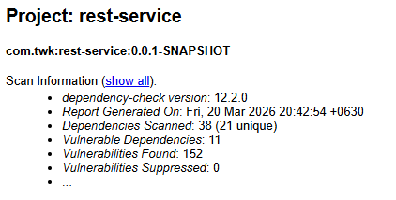

Dependency Check Summary

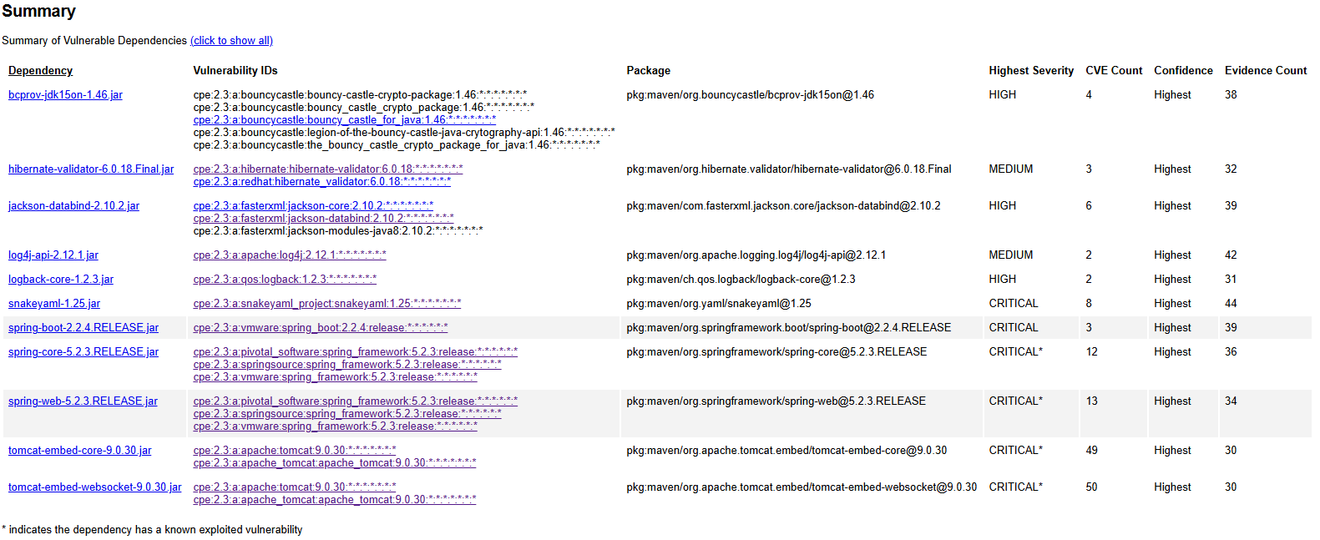

Static Testing Dependency-Check Results

CRITICAL Severity (Highest Risk)

- Tomcat Embed WebSocket 9.0.30
  - CVE Count: 50
  - Description: Presents as an attack vector for multiple WebSocket parsing, authentication bypass, and request smuggling vulnerabilities.
  - Recommended Fix: Upgrade to Tomcat 9.0.80+.
  - CVE Attribution 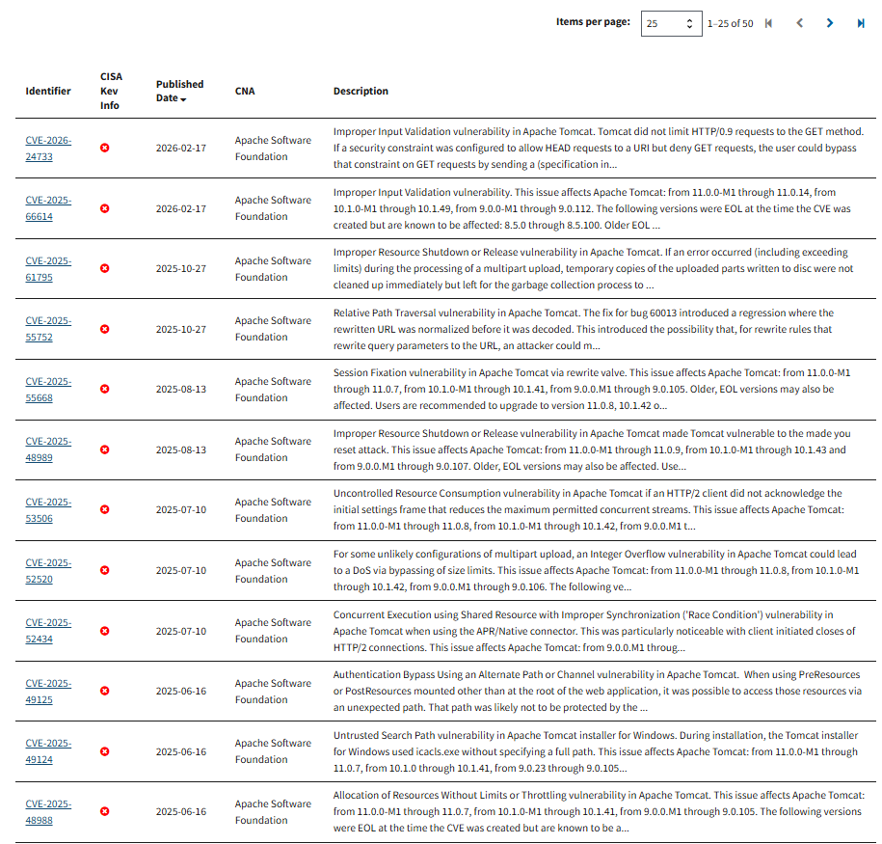
- Tomcat Embed Core 9.0.30
- CVE Count: 49
- Description: Contains dozens of critical issues that could result in DoS attacks, HTTP request smuggling, and information disclosure.
- Recommended Fix: Upgrade to 9.0.80+.
- CVE Attribution: 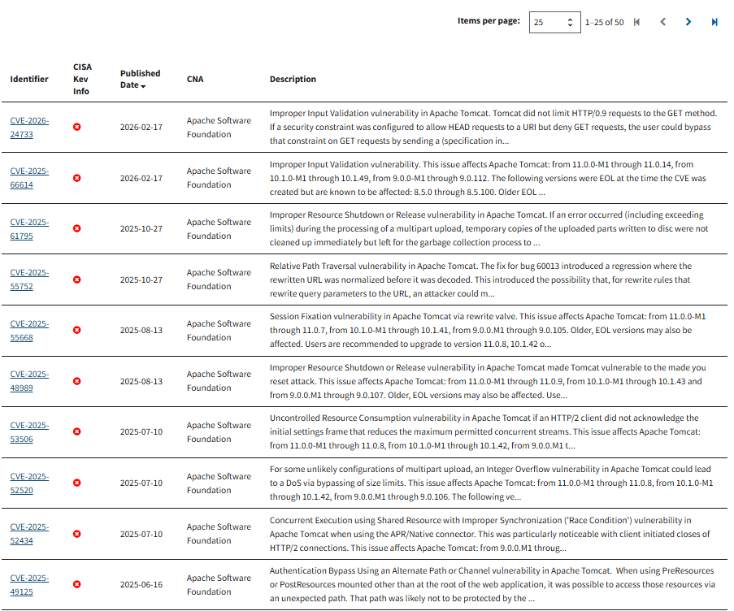

- Spring Web 5.2.3.RELEASE
- CVE Count: 13
- Description: Contains path traversal, unsafe binding, and request handling vulnerabilities.
- Recommended Fix: Upgrade to 5.3.x or 6.x.
- CVE Attribution: 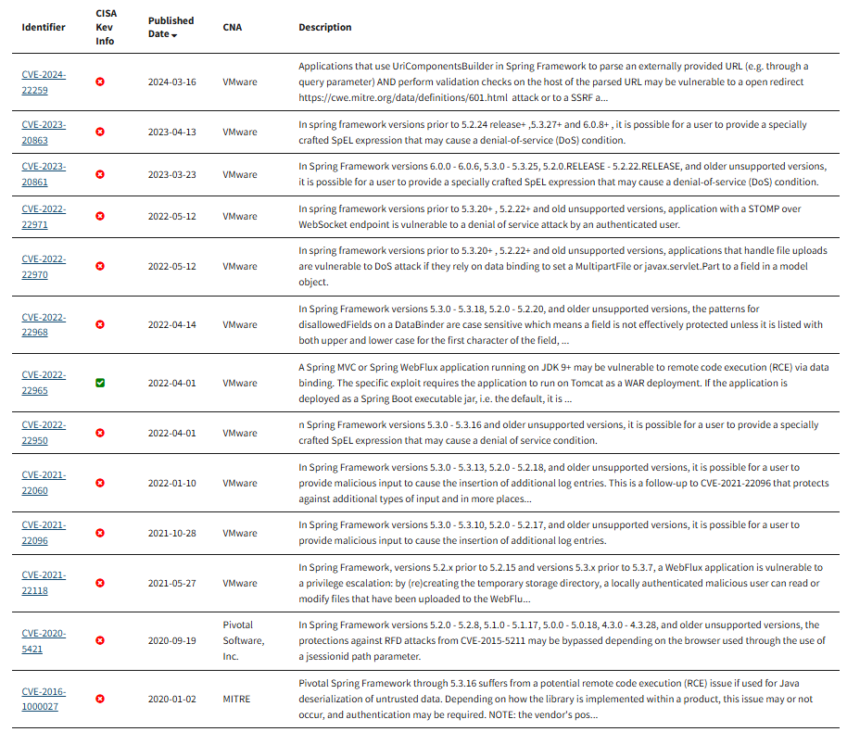

4. Spring Core 5.2.3.RELEASE
- CVE Count: 12
- Description: Includes Spring4Shell (CVE-2022-22965) in certain configurations.
- Fix: Upgrade to 5.3.x or 6.x.
- CVE Attribution: 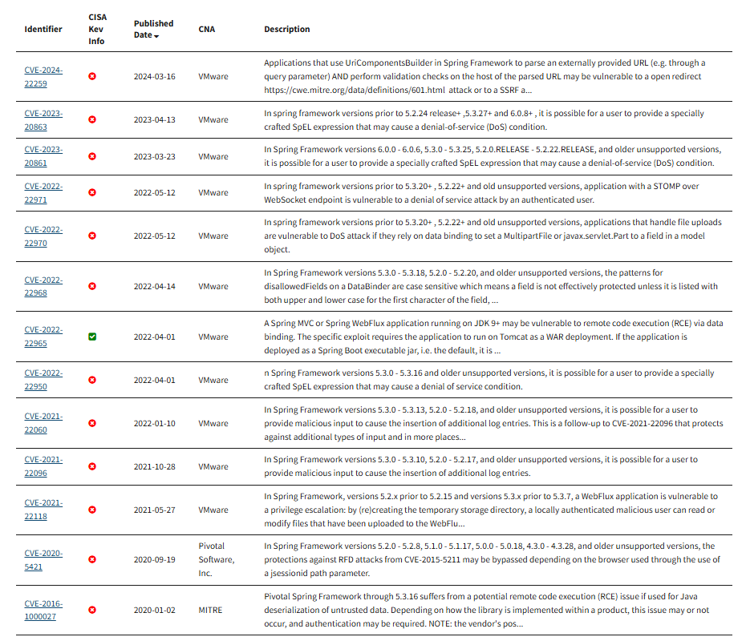

5. SnakeYAML 1.25
- CVE Count: 8
- Description: Contains Unsafe YAML deserialization which could lead to arbitrary code execution attacks.
- Recommended Fix: Upgrade to 2.x.
- CVE Attribution 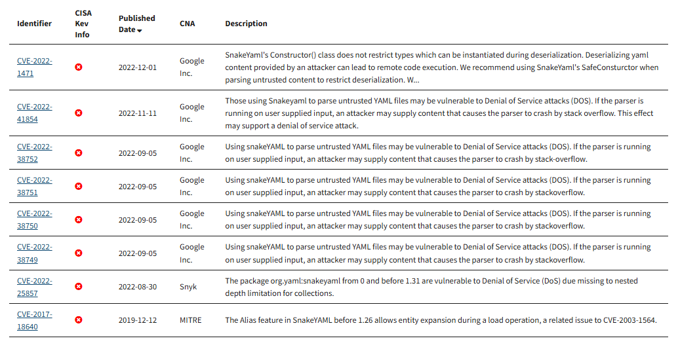

6. Spring Boot 2.2.4.RELEASE
- CVE Count: 3
- Description: Bundles outdated Spring and Tomcat versions with known exploited vulnerabilities.
- Recommended Fix: Upgrade to 2.7.x or 3.x.
- CVE Attribution 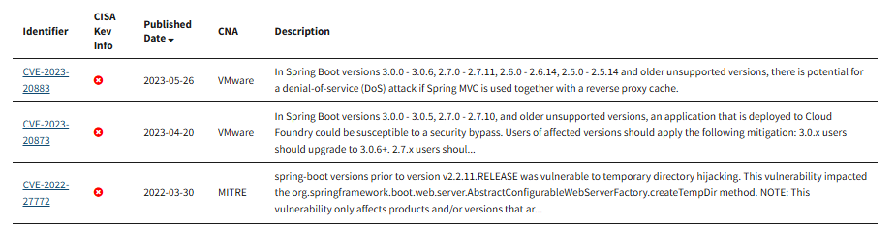

HIGH Severity

7. Jackson Databind 2.10.2
- CVE Count: 6
- Description: Multiple RCE vulnerabilities via unsafe polymorphic deserialization.
- Recommended Fix: Upgrade to 2.13+.
- CVE Attribution 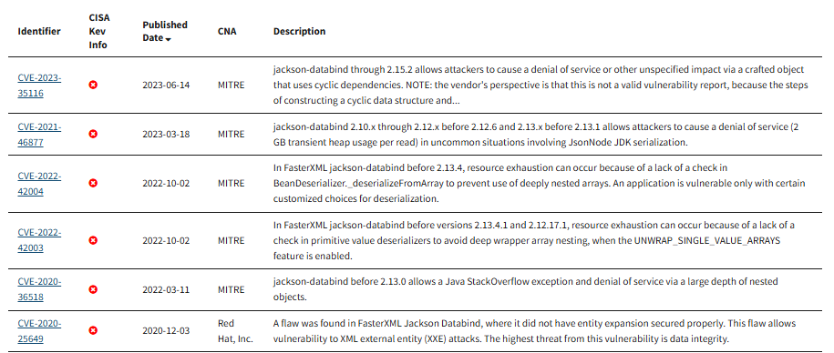

8. Bouncy Castle bcprov-jdk15on 1.46
- CVE Count: 4
- Description: Cryptographic weaknesses and insecure algorithm implementations.
- Recommended Fix: Upgrade to 1.78+.
- CVE Attribution 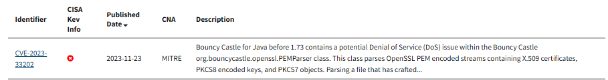

9. Logback Core 1.2.3
- CVE Count: 2
- Description: Malicious configuration injection which could lead to possible code execution.
- Recommended Fix: Upgrade to 1.4.x.
- CVE Attribution 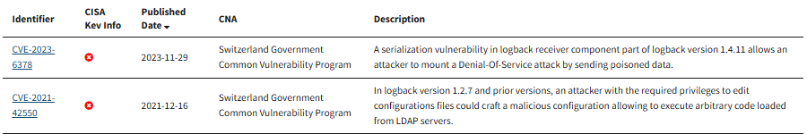

MEDIUM Severity

10. Hibernate Validator 6.0.18.Final
- CVE Count: 3
- Description: Input validation bypass vulnerabilities.
- Recommended Fix: Upgrade to 6.2.x or 7.x.
- CVE Attribution 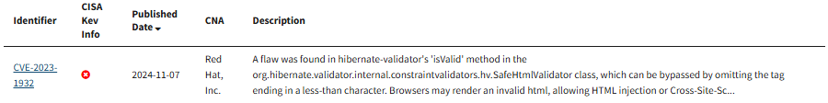 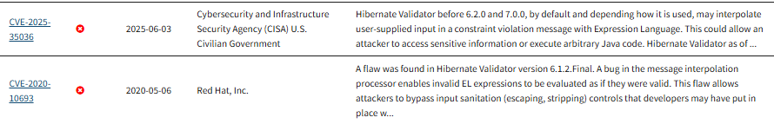

11. Log4j-API 2.12.1
- CVE Count: 2
- Description: DoS and message lookup vulnerabilities.
- Recommended Fix: Upgrade to 2.17.2+.
- CVE Attribution 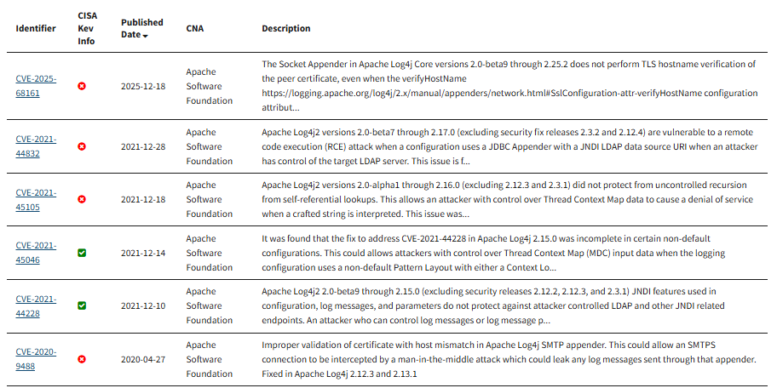

The following components appeared in the summary but had no CVEs:
- classmate‑1.5.1
- jackson‑core‑2.10.2
- jackson‑datatype‑jdk8‑2.10.2
- jakarta.annotation‑api‑1.3.5
- jakarta.validation‑api‑2.0.2
- jboss‑logging‑3.4.1.Final
- jul‑to‑slf4j‑1.7.30
- log4j‑to‑slf4j‑2.12.1
- slf4j‑api‑1.7.30
- tomcat‑embed‑el‑9.0.30

These would still update automatically when Spring Boot gets upgraded.

5. Mitigation Plan

Following the results from the manual code review and static testing, this mitigation plan outlines the steps required to remediate the vulnerabilities identified.

Upgrade Vulnerable Dependencies

High-Priority Upgrades (Critical / Known Exploited)
Component | Action
SnakeYAML 1.25 | Upgrade to 2.x
Spring Boot 2.2.4 | Upgrade to 2.7.x or 3.x
Spring Core 5.2.3 | Upgrade to 5.3.x or 6.x
Spring Web 5.2.3 | Upgrade to 5.3.x or 6.x
Tomcat 9.0.30 | Upgrade to 9.0.80+
Jackson Databind 2.10.2 | Upgrade to 2.13+

Upgrading Spring Boot will automatically update many transitive dependencies.

Secure Input Handling
- Add validation annotations such as @NotBlank, @Size, and @Pattern to controller parameters.
- Validate numeric inputs (e.g., deposit amounts must be positive).
- Implement centralized validation failure handling.

Strengthen API Security
- Add Spring Security with:
  - Authentication (JWT or session-based)
  - Authorization rules per endpoint
- Restrict HTTP methods (GetMapping, @PostMapping, etc.)
- Remove direct exposure of internal objects.

Protect Sensitive Data
- Remove hard-coded credentials from DocData.
- Store secrets in:
  - Environment variables
  - Spring Boot application.properties with encryption
  - A secrets manager such as AWS, Azure, or HashiCorp Vault

Improve Code Quality & Architecture
- Close database connections using try-with-resources.
- Use prepared statements to prevent SQL injection.
- Fix encapsulation issues by making fields private.
- Implement missing methods in myDateTime.
- Refactor confusing method names (e.g., CRUD CRUD()).

Re-run Dependency-Check After Fixes
After upgrading dependencies and refactoring code:
- Re-run the dependency-check scan.
- Verify that all critical and high vulnerabilities are resolved.
- Document any remaining medium/low vulnerabilities and justify acceptance if necessary.

Understanding the importance of secure communication in cybersecurity |. (n.d.). https://wansafe.com/understanding-the-importance-of-secure-communication-in-cybersecurity/?utm_source=copilot.com
Data protection laws of the world. (n.d.). https://www.dlapiperdataprotection.com/
Electronic Communications Privacy Act of 1986 (ECPA) | Bureau of Justice Assistance. (n.d.). Bureau of Justice Assistance. https://bja.ojp.gov/program/it/privacy-civil-liberties/authorities/statutes/1285
Clarke, J. (2026, March 18). Stored Communications Act. Global Relay. https://www.globalrelay.com/resources/the-compliance-hub/rules-and-regulations/stored-communications-act/
47 USC Ch. 15: SECURE AND TRUSTED COMMUNICATIONS NETWORKS. (n.d.). https://uscode.house.gov/view.xhtml?path=/prelim@title47/chapter15&edition=prelim
15 CFR Part 791 -- Securing the Information and Communications Technology and services supply chain. (n.d.). https://www.ecfr.gov/current/title-15/subtitle-B/chapter-VII/subchapter-E/part-791

